The Totalitarians

Part political satire, part bizarre farce, part black comedy by Peter Sinn Nachtrieb

18th June 2022– 24th July 2022

The English Theatre Frankfurt
Teachers’ Resource Pack
This teachers’ pack includes information as well as tasks and topics to be dealt with in the classroom. The tasks do not necessarily build on each other. Cut and paste as you please, and please consult the official program for additional information.

Background Information to The Totalitarians

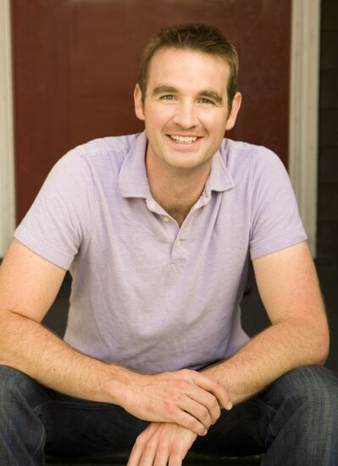
The author – Peter Sinn Nachtrieb
Peter Sinn Nachtrieb is a San Francisco-based playwright whose works include The Totalitarians (NNPN premiere 2014), boom (TCG's most produced play 2009-10), BOB, (2011 Humana Festival for New American Plays at Actor’s Theatre of Louisville, Barrie and Bernice Stavis Award), T.I.C. (Trenchcoat In Common), Hunter Gatherers (2007 ATCA/Steinberg New Play Award, 2007 Will Glickman Prize),Colorado, and Litter: The True Story of the Framingham Dodecutuplets. His work has been seen off-Broadway
and across the country including at Ars Nova, Woolly Mammoth, SPF, Seattle Repertory, Actors Theatre of Louisville, Southern Rep, Kitchen Dog, and in the Bay Area at Z Space, A.C.T., Encore Theatre, Killing My Lobster, Marin Theatre Company, Impact Theatre, and The Bay Area Playwrights Festival. Peter holds a degree in Theater and Biology from Brown and an MFA in Creative Writing from San Francisco State University. Peter is a member of New Dramatists and is Playwright in Residence at Z Space in San Francisco.

The Director – Mark Mineart
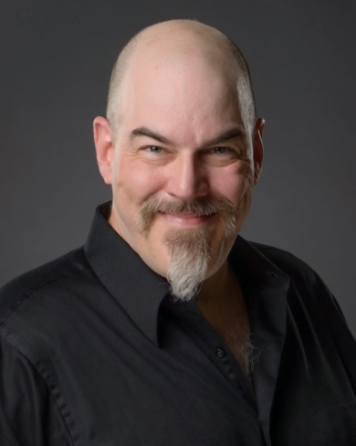
Mark is thrilled to be returning to The English Theatre Frankfurt (ETF) for the European Premiere of The Totalitarians. Previously at ETF: Steve in A Streetcar Named Desire and swing in The Full Monty. Broadway credits include: Julius Caesar with Denzel Washington and Macbeth with Kelsey Grammer. Off Broadway credits: Svejk with Stephen Spinella. Favorite Roles include: Cyrano, Macbeth, Macduff, Cassius, Caliban, Long John Silver and Lennie in Of Mice and Men. World Premiers include: Flaming Guns of the Purple Sage, Natural Selection, Listeners and Under Midwestern Stars. Theatres: Westport Country Playhouse, Actors Theatre of Louisville, Cincinnati Playhouse, Pittsburg Public Theatre, Pioneer Theatre, Geva Theatre, as well as the Indiana, Kansas City, and St. Louis Repertory Theatres, and the Texas, St. Louis, and Utah Shakespeare Festivals.
Film credits: Kinsey with Liam Neeson, Iron Sky with Udo Kier, and What a Man with Man with Matthias Schweighöfer. Television credits: Law & Order, Knights of Prosperity, Oz, and various soaps. After leaving ETF in 2011 Mark ran the Actor Training Program at the American University in Cairo, and currently serves as Associate Professor of Theatre Performance in the Department of Theatre & Dance at Otterbein University in Ohio.

Totalitarians - Synopsis
THE TOTALITARIANS is a raucous dark comedy about the state of modern political discourse, modern relationships, and how easy it is to believe truths without facts. “The Totalitarians” is largely the story of the super-ambitious Francine, a word-crazy aspiring speechwriter getting her ravenously desired first shot as a campaign manager. Her biggest challenge is her candidate, Penelope Easter (Penny) an all-purpose rich and angry housewife with a spotty past and a penchant for embarrassing malapropisms and off-the-cuff remarks about her supposedly gay husband, the son she threw out of the house or the need to get rid of elections.
Francine, married to a doctor, Jeffrey, who is lying to his dying patient- the candidate, complains to him about Penny, who is waiting for Francine to tell her what she stands for. Jeffrey, a well-meaning if semi-proficient general practitioner, questions whether this job is worth all the effort and would rather start a family. Francine, however, does not want to have children at all especially since this would mean that she would have to give up her career.
As Francine, in a hilarious spate of free-association slogan-writing, comes up with the perfect vote-getting meaningless phrase, Jeffrey finds himself drawn to the more passionately emphatic politics of his young, terminal patient Ben, a conspiracy-obsessed protester whose vehement rhetoric comes comically muffled through his ski mask.
As their marriage deteriorates, Francine and Jeffrey simultaneously get closer to their new significant other. While Francine and Penny´s relationship has become more physical than professional, Ben convinces Jeffrey of his conspiracy theory about Penny’s nefarious plans for the Cornhusker State and Jeffrey gets entangled in Ben´s plan: stopping a totalitarian takeover of the Nebraska state government. After a failed and humiliating attempt to convince Francine and fix their marriage, Jeffrey and Ben decide to interfere in Penny´s next rally. As Ben reveals himself as Penny´s unwanted, abandoned son in public, mother and son attack each other violently, resulting in the killing of each other in an act of revenge in front of the cheering crowd.

The Characters

Francine Jefferson
Francine is a so far unsuccessful speech writer in her 30s/early 40s, who lives on Nebraska´s countryside, because her husband opened a doctor´s office there. Francine does not want to start a family and be housewife and mother only, but wants to have a career for herself. In supporting Penny, whom she personally does not believe in, she hopes to finally get her career started.

Penelope (Penny) Easter
Penny is a long-shot candidate for a vaguely defined position in the Nebraska state government. Easter is a faux-folksy former professional roller skater who seemingly has gotten into politics to escape middle-age boredom. She does not seem to have political ideas of her own or any other ambition but power. In her private life, she has five children and a husband whom she constantly ascribes to be gay. She herself starts a sexual relationship with Francine.
Penny´s character bears a resemblance to contemporary republican candidates, especially Sarah Palin but also Donald Trump.

Jeffrey Jefferson
Jeffrey is Francine´s husband. He has his own doctor´s office in Nebraska and would love to start a family with Francine. He strikes a deal with her that the outcome of the election will decide on their future path.
While Francine works hard for Penny and is barely home, Jeffrey treats Ben – a terminal patient. Jeffrey cannot bring himself to tell Ben he is going to die and starts to conspire with Ben against Penny´s campaign.

Ben
Ben is Jeffrey´s manic, compelling patient, who has a revolutionary bent and a head full of conspiracy theories. Not knowing that he is going to die soon, Ben plans to sabotage Penny´s election campaign, claiming that she wants to turn Nebraska in a totalitarian state.
Later, he reveals that he really is Penny´s son, who is responsible for his brother´s death. Consequently, his mother kicked him out, which led him to seeking revenge.

Important Vocabulary
Political context
An election | a formal and organized choice by vote of a person for a political office or other position
To vote | to express your choice or opinion, especially by officially writing a mark on a paper or by raising your hand or speaking in a meeting
a speech  To give a speech | a formal talk which someone gives to an audience
To obtain  To obtain a position of power | get, acquire, or secure (something)
A staff | all the people employed by a particular organization
The establishment | a dominant group or elite that controls a polity or an organization
To oppress | to govern people in an unfair and cruel way and prevent them from having opportunities and freedom
To be under investigation | being looked into to try to find out the facts
A contender | Someone who competes with other people to try to win something
To pursue sth.  The pursuit of happiness | try to do it or achieve it, usually over a long period of time
A riot | an occasion when a large number of people behave in a noisy, violent, and uncontrolled way in public, often as a protest
Mandate | the authority given to an elected group of people, such as a government, to perform an action or govern a country
The disenfranchised | people not having the right to vote, or a similar right, or having had that right taken away
The populace | people who live in a particular country or place, or ordinary people
Totalitarian regime | A political system in which those in power have complete control and do not allow people freedom to oppose them
Focus group | a group of people assembled to participate in a discussion about a product before it is launched, or to provide feedback on a political campaign.
Conspiracy Theory | the activity of secretly planning with other people to do something bad or illegal
Medical context
A nubbin | something small or undeveloped, small lump
A hernia | a medical condition in which an organ pushes through the muscle which surrounds it
A colon | the lower and bigger half of the bowels
Achilles heel | a small problem or weakness in a person or system that can result in failure
To eviscerate | to remove one or all of the organs from the inside of a body
A mass like a cauliflower | Mass: a lump in the body caused by the abnormal growth of cells, a cyst, hormonal changes, or an immune reaction. A mass may be benign (not cancer) or malignant (cancer).  Cauliflower: a large, round, white form of cabbage that is eaten cooked or uncooked

Nebraska
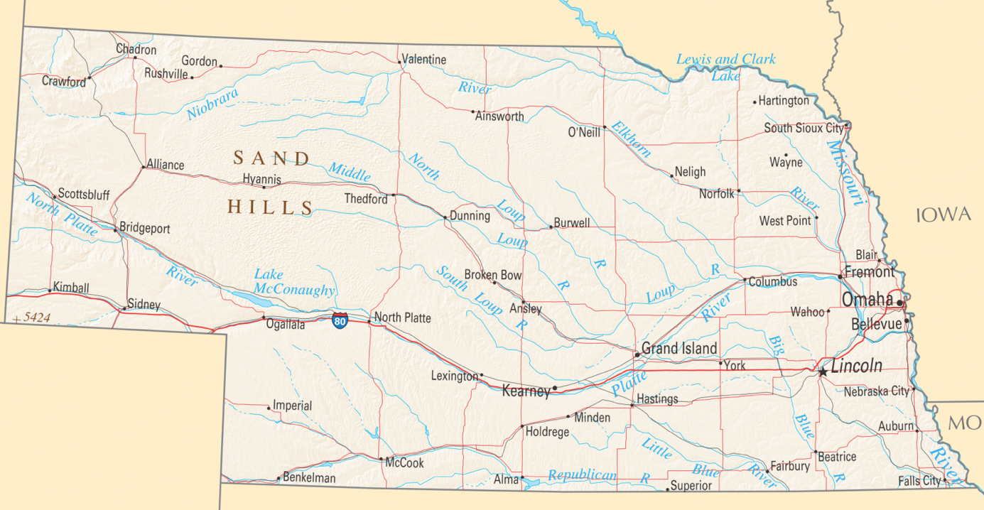
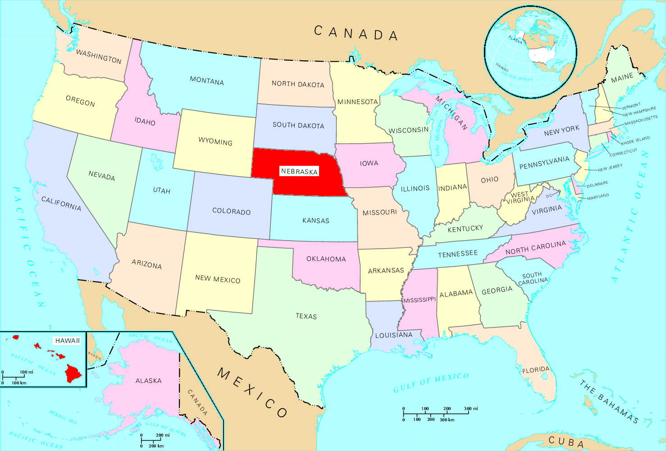

Nebraska (/nəˈbræskə/) is a state in the Midwestern region of the United States.
Indigenous peoples, including Omaha, Missouria, Ponca, Pawnee, Otoe, and various branches of the Lakota (Sioux) tribes, lived in the region for thousands of years before European exploration.
Nebraska’s area is just over 77,220 square miles (200,000 km²) with a population of over 1.9 million. Its capital is Lincoln, and its largest city is Omaha, which is on the Missouri River. Nebraska was admitted into the United States in 1867, two years after the end of the American Civil War. The Nebraska Legislature is unlike any other American legislature in that it is unicameral, and its members are elected without any official reference to political party affiliation.
Nebraska is composed of two major land regions: the Dissected Till Plains and the Great Plains. The Dissected Till Plains region consists of gently rolling hills and contains the state’s largest cities, Omaha and Lincoln. The Great Plains region, occupying most of western Nebraska, is characterized by treeless prairie. Nebraska has two major climatic zones. The eastern two-thirds of the state has a humid continental climate. The Panhandle and adjacent areas bordering Colorado have a primarily semi-arid climate.
Violent thunderstorms and tornadoes occur primarily during spring and summer and sometimes in autumn.
Nebraska was admitted into the Union in 1867 as the 37th state. Its nickname, “Cornhusker State,” refers to the way that corn (a leading product of the state) was commonly harvested, “husking” it by hand, before the invention of husking machinery.

Speeches and slogans in USA election campaigns
Political speeches are the crucial activity that links the different parts of society together and allow them to be as united entire. The core of political speech is the ability of the politician to use language and symbols that wake latent tendencies among the masses. Politics is a means for power in order to put certain political, economic and social concepts into practice. Language plays an essential role, for every political action is prepared, attended, influenced and played by language.so language and politics are closely interleaved. The main objective of political speech is to get the corresponding effect through persuasion. Politicians wish to increase people’s interest and to strengthen their image, to make people share their opinions and to agree with their ideas to inform the general public of their ideology and message.
The “stump speech” is a term that describes the core speech that a candidate or party leader gives on almost every occasion with appropriate modifications for different audiences and situations. The stump speech is an elaboration of the campaign message. It introduces the candidate to voters, lets them know what he/she is running for and what he/she plans to do if elected, and tells them about the kind of person he/she is. Like all other campaign communications, the stump speech should be based on the candidate´s main message and written to reach the potential supporters the campaign has identified as target audiences.

Each element of a speech has its own particular characteristics and purpose. When these are tied together, they create a structure that allows your speech to flow with ease and logic, making it easier for the audience to follow.

Opening name, position, and why the candidate is running for it.
Connection Establish a connection with the audience by demonstrating a shared concern. Problem What problem are you running for office to solve? How does it affect the
audience?
Solution Describe the problem and say why you care about it. Describe your solution and how it benefits voters. What specifically will you do or fight for if elected?
Vision Describe how things could be better and what kind of future you will work for.
How would the community be different if this problem were solved?
Call to Action Ask your audience to make a difference by voting for you and supporting your
campaign.
Closing Summarize why you are running, restate your call to action and thank the
audience.

Often, politicians use recurring and recognizable slogans, to underline and sum up their message briefly.
To rise above the fray and generate momentum among supporters, political campaigns have long relied on slogans such as Barack Obama’s “Yes, we can.” Much like Harris borrowed the slogan from Obama, Obama himself borrowed the words from Cesar Chavez and Dolores Huerta who used the Spanish version (“Si, se puede”) to mobilize the United Farm Workers in the 1970s.
But Harris’s use of the slogan on the debate stage in Houston didn’t have nearly the same impact it did in Obama’s stump speeches in 2008. Context and message resonance have as much to do with the effectiveness of slogans as do the poetic ring of the chosen words.
At the most basic level, political slogans must provide easily repeatable taglines for campaigns. But for political slogans to truly do valuable political work, they need to resonate with a candidate’s larger campaign message.
“Political slogans are designed to by witty, catchy, and most importantly, highly quotable,” carrying the campaign message far and wide (Hodges 2014). To those ends, a certain content bias—a term Nicholas Enfield (2008) uses to discuss a linguistic variant’s intrinsic properties—must be met to make a phrase memorable and repeatable. For a successful political slogan, this means a certain aesthetic appeal that arises from leveraging the poetic function of language.
More important than a slogan’s intrinsic appeal is the way it enters into specific contexts of situation, draws from previous contexts, and resonates with a candidate’s larger campaign theme. Obama’s “Yes, we can” slogan demonstrates all these elements.

The satire, farce, and black comedy “The Totalitarians”

Black comedy, also known as black humor, dark humor, dark comedy, morbid humor, or gallows humor, is a style of comedy that makes light of subject matter that is generally considered taboo, particularly subjects that are normally considered serious or painful to discuss. Writers and comedians often use it as a tool for exploring vulgar issues by provoking discomfort, serious thought, and amusement for their audience. Thus, in fiction, for example, the term black comedy can also refer to a genre in which dark humor is a core component.
Popular themes of the genre include death, crime, poverty, suicide, war, violence, terrorism, discrimination, disease, racism, sexism and human sexuality.

Satire is a literary device for the artful ridicule of human and/or societal flaws, discrepancies, and inadequacies as a means of exposing or correcting it. The subject of satire is generally human frailty, as it manifests in people’s behavior or ideas as well as societal institutions or other creations. Satire utilizes tones of amusement, contempt, scorn, or indignation towards a flawed subject with the hope of provoking an audience and challenging viewpoints, creating awareness and subsequent change.
Satire relies on audience recognition of a systemic problem underlying the ridicule and humor. Therefore, though satire does intend to be humorous, the motive is a greater common understanding of humanity and society rather than generating laughter.
Political satire is satire that specializes in gaining entertainment from politics; it has also been used with subversive intent where political speech and dissent are forbidden by a regime, as a method of advancing political arguments where such arguments are expressly forbidden.
Political satire is usually distinguished from political protest or political dissent, as it does not necessarily carry an agenda nor seek to influence the political process. While occasionally it may, it more commonly aims simply to provide entertainment. By its very nature, it rarely offers a constructive view in itself; when it is used as part of protest or dissent, it tends to simply establish the error of matters rather than provide solutions.
A farce is a literary genre and type of comedy that makes use of highly exaggerated and funny situations aimed at entertaining the audience. Farce is also a subcategory of dramatic comedy, which is different from other forms of comedy as it only aims at making the audience laugh. It uses elements like physical humor, deliberate absurdity, bawdy jokes, and drunkenness just to make people laugh. We often see one-dimensional characters in ludicrous situations in farces.
Although a farce may appear only to be funny, they often contain deeper implications on account of the use of satirical elements. In terms of plots, farces are often incomprehensible; hence, the audiences are not encouraged to follow the plot in order to avoid becoming overwhelmed and confused. Moreover, farces also contain improbable coincidences, and generally mock weaknesses of humans and human society.

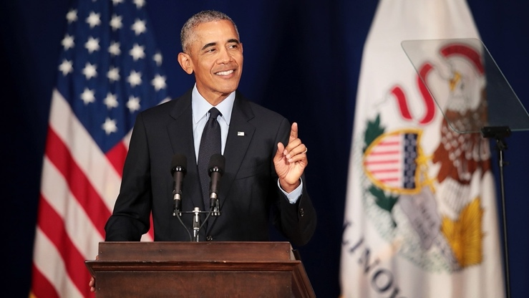
Pre-Watching Activities

The art of giving a speech
- Brainstorm - maybe with a wordcloud (i.e. Mentimeter):
What are characteristics of a good speech?

- Watch Barack Obama´s Presidential Announcement speech from 2007.
(minute 0.59 through minute 6.55) https://www.youtube.com/watch?v=gdJ7Ad15WCA

Or
Yes we can speech. (minute 1 through minute 10.35)
https://www.nytimes.com/2008/01/08/us/politics/08text-obama.html
https://www.youtube.com/watch?v=Fe751kMBwms

- Briefly talk about content, addressee and circumstances.
- Watch it again. While watching: Do not concentrate on content mainly, but on body language, intonation, sentence structure etc.
- What do you recognize? Add additional characteristics of a good speech to your notes from the beginning of the lesson.

- Read the excerpt from “The Totalitarians”
Penny runs for a political position and gives her first campaign speech, written by her campaign manager, Francine.
September 7, 2018

Excerpt The Totalitarians
I want to address one of the biggest questions of the campaign so far. Who is Penelope Easter? Me. Who am I? What is she/I about? Is/am she/I the one who will do what I/you want?
Some of ya have no idea.
You might not have followed my success in the professional roller-skating circuit, been affected by my charity work, or you might not have heard a hoot about all the doable plans we´ve been hatching over in Haye Springs.
You might know what they want you to know about me. That sometimes I put my “foot in my mouth.” Sometimes I confuse “my grains and what they are sheathed in”. And I have a husband wo “likes special things.” I´m not going to bestow any dignity to the elitist attacker naypeople by addressing their vicious teapot gossip. But I will address you, the people of Nebraska, the voters with a choice who a probing their hearts to decide if I am the right candidate to dimple their chad for.
To answer your question I must first ask my own: Who are you?
Seriously, who are ya? What´s your sign? Why did you come here? Wearing those sandals? With that face? Do you think you deserve the great things I could do for you simply because you exist? Because your mommy said you were special? Seriously, what makes you worth fighting for?
A campaign is a date. Between you and me. And we´re dancing, we´re getting drinks, we´re touching each other´s shoulders, and our nipples are paying attention, but I need more if we´re gonna be an L.T.R. I don´t want to be “one of those” couples who are all lovey-dovey until compromise und sacrifice transform them into resentful sacks. ´Cause let me tell you, if we want a bright future, we´re gonna need a more perfect union than that.
For as we can all feel, these are not good times. These are bad bad times. So frippin bad that even the rights we thought were uninalienable are under a full assault. Life is under attack. Murderers. Viruses. Avoidable accidents. And, of course, all the senseless tragedies like what happened right here in North Platte. Why a shotput? Why a christening? Will we ever be able to bowl the same way again?
I too, bled with you on that day. I don´t think my opponent, with his bulletproof Cadillacs and access to medicine, really understands the corporeal threats day after day and how we all could die (Snaps fingers.) just like that. I understand. And I´m not gonna let them get ya. I, Penelope Easter, will fight for your life. Will you fight for mine?
Liberty is under attack. No smoking. No parking. You can´t eat that it´s got corn in it.
Have you read my opponent´s platform? He thinks you gotta think everything he thinks. Now tell me what relationship works well like that? Maybe if you´re servant in his court and this is England. Maybe if you´re prostitute and he´s your pimp and you´re still paying off your trip from Indonesia.
Unlike my opponent, I don´t think you´re my whore to keep in line. I respect you, your idiosyncrasies, your need to put career before family, and I don´t give a hoot if you like to drive with or without your seatbelt. For I, Penelope Easter, will fight for your liberty. Will you fight for mine?
And oh boy is pursuing happiness under attack. I don´t think my opponent believes in mirth. He doesn´t want you pursuing anything at all ´cause that makes you free and makes him weak. He wants you to believe your dreams are selfish, silly, and unachievable, you’re not good enough, you´re never gonna get what you desire anyway so give up, lay back and submit to the mediocre plan that´ll wet the dreams of Daddy Mister Him. Well I say we get together and shove my opponent´s plans for us up his hoo-ha´ cause I, Penelope Easter, will fight for your happiness. Will you fight for mine?
I am not my opponent. And that´s who I am so let me ask again, who are you?
You know what I´m going to do. Who are you?
You know it in your hearts that this woman before you´s gonna cook up one hearty stew for Nebraska. What´re you bringing to this potluck? You gonna help me cook? You gonna set the table? You gonna pour me a glass of wine while I brown this meat? While you´re at it you wanna make the bed? You wanna get in bed with me? You wanna takes this date to its inevitable drunken conclusion? Well C´MON NOW let´s cozy up in this Nebraskan king-size we´re all oiled up in and work together for a tomorrow so bright that it can tear down tyranny with its beams of light. A tomorrow so clear that it can out-sparkle the inky coal menace of entropy and decay. A tomorrow so hot and rich that it can pour hope like molten gold from a cauldron, coating every step of our future.
Together, let us march down our golden roads and boldly stroll into our dreams and we, we will not fall, we will not fail, we will not look down, cower, nor cry, ´cause you got me and I got you and together we will find Life Liberty Happiness and Freedom. Freedom from Fear!

- Share your first impression of the speech in class.
- Talk about similarities and differences to the Obama speech. If necessary, watch the video again or read the transcript of Obama´s speech.
- Discuss whether the differences mean, that the way of presenting it needs to be adjusted too.
- Prepare a presentation of Penny´s speech. Think about all the characteristics of a good speech you worked on and prepare your text accordingly.
- Mark the words you want to emphasize
- Mark phrases according to speed of reading
- Think of gestures you can use to stress the content
- …
11) Divide up the speech into parts and present it in a way that everybody gets to cover a
part of the speech.
Give each other feedback. Go through the speech and let every student present a part of it.

While Watching Activities

Comprehension Quiz
- Who´s Jeffrey?
- Francine´s building supervisor, who works part time as a nurse
- Francine´s husband who is a doctor
- Penny´s husband who is a doctor
- Penny´s son who is an activist

- Which statement describes Francine´s and Jeffrey´s arrangement best?
- Francine and Jeffrey are engaged and will get married after Penny´s election.
- Jeffrey and Francine live together as roommates and want to take in another tenant in order to lower their rental fee.
- If Francine successfully helps Penny win the election, her career comes first and Jeffrey and her will leave Nebraska. If Penny does not win, Francine and Jeffrey stay in Nebraska and start a family.
- If Francine continues to work for Penny, Jeffrey will divorce her.

- What is Penny Easter´s slogan?
- Freedom from fear
- Fridays for Future
- You Do Not Talk About Fight Club
- Just do it.

- Francine and Penny agree on a visual for the slogan. What is it?
- A T-shirt
- A graffiti
- A tattoo
- A rally rag

- Apart from sabotaging her career, what else does Francine accuse Jeffrey of?
- She accuses him of being a bad doctor and of having killed her mother in consequence
- She accuses him of viciousness and laziness.
- She accuses him of staying out all night and of his disability to communicate.
- She accuses him of sexism and patriarchal behavior, reducing her to her reproductive qualities.

- Why does Ben destroy Jefferey’s phone?
- Because Jeffrey is constantly distracted by his phone, and Ben wants to have his full attention.
- Because he is scared that its radiation could aggravate his cancer.
- Because he suspects Jeffrey to be wired with his phone which might be used as a tracking device.
- Because he was raised in an Amish community and rejects technology.

- What will Penny allegedly do after winning the campaign?
- She will introduce a law prohibiting the sale of weapons.
- She will turn Nebraska into a Totalitarian state.
- She will raise taxes for high income earners and build community housing.
- She will introduce a national social insurance system.

- According to Ben, what is the organization of four?
- The Organization of the Petroleum Exporting Countries who are blackmailing Penny by controlling her personal oil prices.
- Four people with power who placed allies in important political and economical positions in order to take over Nebraska with Penny as their figurehead.
- Himself, his mother, father, and brother, forming a family of four.
- A small self-help group for cancer patients, which Ben hast reluctantly joined due to Jeffreys encouragement.

- In the past, Penny kicked out a son of hers. Why?
- He had arranged to get one of his brothers killed.
- His grades did not meet her expectations.
- He killed his brother.
- He allowed the family dog to escape.

- Who is Ben? Choose the most fitting answer.
- Ben is an activist, Jeffrey´s friend and originally from Alaska.
- Ben is an activist, Penny´s son and he is dying of cancer.
- Ben is suffering from a hernia, he is a psychopath, who had his brother killed, and is Penny´s son.
- Ben is Jeffreys patient who has recovered from cancer and now wants to follow a career in politics.

- 8-10 correct answers | 4-9 correct answers | 0-3correct answers
JJ  Congratulations! You understood a lot! | J  Quite good already! Talk to your classmates again about the play, you might tap into new levels of understanding! | K  Don´t give up! Talk to your classmates about the parts of the play that are still a bit fuzzy to you.

Speech Analysis

Analyze Penny Easter´s speech. Address:

structure,

strategies (does she inform and argue or polarize and manipulate? How?),

rhetoric devices and imagery

as well as syntax and vocabulary

Post-Watching Activity

Write your own Speech

You are Penny´s opponent´s speech writer. Write your own speech!

Go online and look up crucial information about Nebraska and its citizens. Think about a possible target audience and the issues they might be interested in.

Think about your political goals for Nebraska

Think of keywords related to your goals which will be stressed and repeated in your speech

Think of a slogan

Include Imagery and rhetoric devices

Use the information you gathered about aspects of speeches

The speech´s presentation should take 3-5 minutes.

In the next step you are Penny´s opponent. Exchange speeches and prepare your classmate´s speech.

Present.

Appendix

Barack Obama´s Speeches

Barack Obama's campaign speech
The Illinois senator this afternoon formally announced he will seek the Democratic nomination for president in 2008. Here is the full transcript of his speech
Sat 10 Feb 2007
Let me begin by saying thanks to all you who've traveled, from far and wide, to brave the cold today.
We all made this journey for a reason. It's humbling, but in my heart I know you didn't come here just for me, you came here because you believe in what this country can be. In the face of war, you believe there can be peace. In the face of despair, you believe there can be hope. In the face of a politics that's shut you out, that's told you to settle, that's divided us for too long, you believe we can be one people, reaching for what's possible, building that more perfect union.
That's the journey we're on today. But let me tell you how I came to be here. As most of you know, I am not a native of this great state. I moved to Illinois over two decades ago. I was a young man then, just a year out of college; I knew no one in Chicago, was without money or family connections. But a group of churches had offered me a job as a community organizer for $13,000 a year. And
I accepted the job, sight unseen, motivated then by a single, simple, powerful idea - that I might play a small part in building a better America.
My work took me to some of Chicago's poorest neighborhoods. I joined with pastors and lay-people to deal with communities that had been ravaged by plant closings. I saw that the problems people faced weren't simply local in nature - that the decision to close a steel mill was made by distant executives; that the lack of textbooks and computers in schools could be traced to the skewed priorities of politicians a thousand miles away; and that when a child turns to violence, there's a hole in his heart no government could ever fill.
It was in these neighborhoods that I received the best education I ever had, and where I learned the true meaning of my Christian faith. After three years of this work, I went to law school, because I wanted to understand how the law should work for those in need. I became a civil rights lawyer, and taught constitutional law, and after a time, I came to understand that our cherished rights of liberty and equality depend on the active participation of an awakened electorate. It was with these ideas in mind that I arrived in this capital city as a state Senator.
It was here, in Springfield, where I saw all that is America converge - farmers and teachers, businessmen and laborers, all of them with a story to tell, all of them seeking a seat at the table, all of them clamoring to be heard. I made lasting friendships here - friends that I see in the audience today.
It was here we learned to disagree without being disagreeable - that it's possible to compromise so long as you know those principles that can never be compromised; and that so long as we're willing to listen to each other, we can assume the best in people instead of the worst.
That's why we were able to reform a death penalty system that was broken. That's why we were able to give health insurance to children in need. That's why we made the tax system more fair and just for working families, and that's why we passed ethics reforms that the cynics said could never, ever be passed.
It was here, in Springfield, where North, South, East and West come together that I was reminded of the essential decency of the American people - where I came to believe that through this decency, we can build a more hopeful America.
And that is why, in the shadow of the Old State Capitol, where Lincoln once called on a divided house to stand together, where common hopes and common dreams still, I stand before you today to announce my candidacy for President of the United States.

Barack Obama’s New Hampshire Primary Speech
Formularbeginn
Formularende
Jan. 8, 2008
The following is a transcript of Senator Barack Obama's speech to supporters after the New Hampshire primary, as provided by CQ Transcriptions via The Associated Press.
BARACK OBAMA: Thank you, New Hampshire. I love you back. Thank you. Thank you.
Well, thank you so much. I am still fired up and ready to go. (APPLAUSE)
Thank you. Thank you.
Well, first of all, I want to congratulate Senator Clinton on a hard-fought victory here in New Hampshire. She did an outstanding job. Give her a big round of applause.
(APPLAUSE)
You know, a few weeks ago, no one imagined that we'd have accomplished what we did here tonight in New Hampshire. No one could have imagined it.
For most of this campaign, we were far behind. We always knew our climb would be steep. But in record numbers, you came out, and you spoke up for change.
And with your voices and your votes, you made it clear that at this moment, in this election, there is something happening in America.
There is something happening when men and women in Des Moines and Davenport, in Lebanon and Concord, come out in the snows of January to wait in lines that stretch block after block because they believe in what this country can be.
There is something happening. There's something happening when Americans who are young in age and in spirit, who've never participated in politics before, turn out in numbers we have never seen because they know in their hearts that this time must be different.

There's something happening when people vote not just for party that they belong to, but the hopes that they hold in common.
And whether we are rich or poor, black or white, Latino or Asian, whether we hail from Iowa or New Hampshire, Nevada or South Carolina, we are ready to take this country in a fundamentally new direction.
That's what's happening in America right now; change is what's happening in America.
You, all of you who are here tonight, all who put so much heart and soul and work into this campaign, you can be the new majority who can lead this nation out of a long political darkness.
Democrats, independents and Republicans who are tired of the division and distraction that has clouded Washington, who know that we can disagree without being disagreeable, who understand that, if we mobilize our voices to challenge the money and influence that stood in our way and challenge ourselves to reach for something better, there is no problem we cannot solve, there is no destiny that we cannot fulfill. Our new American majority can end the outrage of unaffordable, unavailable health care in our time. We can bring doctors and patients, workers and businesses, Democrats and Republicans together, and we can tell the drug and insurance industry that, while they get a seat at the table, they don't get to buy every chair, not this time, not now.
(APPLAUSE)
Our new majority can end the tax breaks for corporations that ship our jobs overseas and put a middle-class tax cut in the pockets of working Americans who deserve it.
We can stop sending our children to schools with corridors of shame and start putting them on a pathway to success.
We can stop talking about how great teachers are and start rewarding them for their greatness by giving them more pay and more support. We can do this with our new majority.
We can harness the ingenuity of farmers and scientists, citizens and entrepreneurs to free this nation from the tyranny of oil and save our planet from a point of no return.
And when I am president of the United States, we will end this war in Iraq and bring our troops home.
(APPLAUSE)
We will end this war in Iraq. We will bring our troops home. We will finish the job -- we will finish the job against Al Qaida in Afghanistan. We will care for our veterans. We will restore our moral standing in the world.
And we will never use 9/11 as a way to scare up votes, because it is not a tactic to win an election. It is a challenge that should unite America and the world against the common threats of the 21st century: terrorism and nuclear weapons, climate change and poverty, genocide and disease.
All of the candidates in this race share these goals. All of the candidates in this race have good ideas and all are patriots who serve this country honorably.
(APPLAUSE)
But the reason our campaign has always been different, the reason we began this improbable journey almost a year ago is because it's not just about what I will do as president. It is also about what you, the people who love this country, the citizens of the United States of America, can do to change it.
That's what this election is all about.
That's why tonight belongs to you. It belongs to the organizers, and the volunteers, and the staff who believed in this journey and rallied so many others to join the cause.
We know the battle ahead will be long. But always remember that, no matter what obstacles stand in our way, nothing can stand in the way of the power of millions of voices calling for change.
We have been told we cannot do this by a chorus of cynics. And they will only grow louder and more dissonant in the weeks and months to come.
We've been asked to pause for a reality check. We've been warned against offering the people of this nation false hope. But in the unlikely story that is America, there has never been anything false about hope.
(APPLAUSE)
For when we have faced down impossible odds, when we've been told we're not ready or that we shouldn't try or that we can't, generations of Americans have responded with a simple creed that sums up the spirit of a people: Yes, we can. Yes, we can. Yes, we can.

Answers Quiz
- Who´s Jeffrey?

B Francine´s husband who is a doctor

- Which statement describes Francine´s and Jeffrey´s arrangement best?
C If Francine successfully helps Penny win the election, her career comes first and Jeffrey and her will leave Nebraska. If Penny does not win, Francine and Jeffrey stay in Nebraska and start a family.

- What is Penny Easter´s slogan?
A Freedom from fear

- Francine and Penny agree on a visual for the slogan. What is it?
C A tattoo

- Apart from sabotaging her career, what else does Francine accuse Jeffrey of?
A She accuses him of being a bad doctor and of having killed her mother in consequence

- Why does Ben destroy Jefferey’s phone?
C Because he suspects Jeffrey to be wired with his phone which might be used as a tracking device.

- What will Penny allegedly do after winning the campaign?
B She will turn Nebraska into a Totalitarian state.

- According to Ben, what is the organization of four?
B Four people with power who placed allies in important political and economical positions in order to take over Nebraska with Penny as their figurehead.

- In the past, Penny kicked out a son of hers. Why?
A He had arranged to get one of his brothers killed.

- Who is Ben? Choose the most fitting answer.
B Ben is an activist, Penny´s son and he is dying of cancer.

https://ctxlivetheatre.com/reviews/review-the-totalitarians-by-theatre-en-bloc/ https://www.dramatists.com/cgi-bin/db/single.asp?key=5287 https://www.sfgate.com/performance/article/Totalitarians-review-Campaign-gets-nastier-5914382.php https://www.dramatists.com/cgi-bin/db/single.asp?key=5287 https://www.sfgate.com/performance/article/Totalitarians-review-Campaign-gets-nastier-5914382.php https://www.dramatists.com/cgi-bin/db/single.asp?key=5287
In comparison: Germany´s area is 357.588 km² with a population of 83,24 million
Bicameralism: lawmaking body of a country that comprises of two separate houses, i.e. the Upper house and the Lower house. The members of the lower house are elected directly by the people through general elections to represent the general public. On the other hand, the indirect method is used to elect members of the Upper house, which indicates political subdivisions. Unicameralism: there is only one house to perform all the activities of the legislature, i.e. enacting laws, passing a budget, looking after administration, discussion on matters concerning developmental plans, international relations, national plans etc.
https://www.ipl.org/essay/The-Importance-Of-Political-Speech-PK8DSCR74ACP6 https://www.ndi.org/sites/default/files/Module%207_Becoming%20a%20Powerful%20Communicator_EN.pdf https://www.anthropology-news.org/articles/yes-we-can-and-the-power-of-political-slogans/
https://literarydevices.net/comedy/ https://literarydevices.net/satire/ https://literarydevices.net/farce/ https://en.wikipedia.org/wiki/Black_comedy https://en.wikipedia.org/wiki/Political_satire
This speech is a bit shorter and varies more in terms of body language.
This speech is longer but the effectiveness of repetitions as well as the importance of an effective slogan gets clearer.
Full speech: https://www.theguardian.com/world/2007/feb/10/barackobama
Full speech: https://www.nytimes.com/2008/01/08/us/politics/08text-obama.html

